📝 Introduction

This tutorial is dedicated to learning routing in a network, such as looking at routing tables and to dynamic routing with OSPF. Task 1 uses a small network that has several subnets and builds up to monitor the functionality of routing tables and forwarding. Task 2 involves OSPF which handles automatically between the routers and adjusts to changes in the network.

Task 1: This requires creating a network and seeing routing tables as forwarding is enabled on a router.
Task 2 involves the study of dynamic routing with OSPF and the routes change as the network is altered.

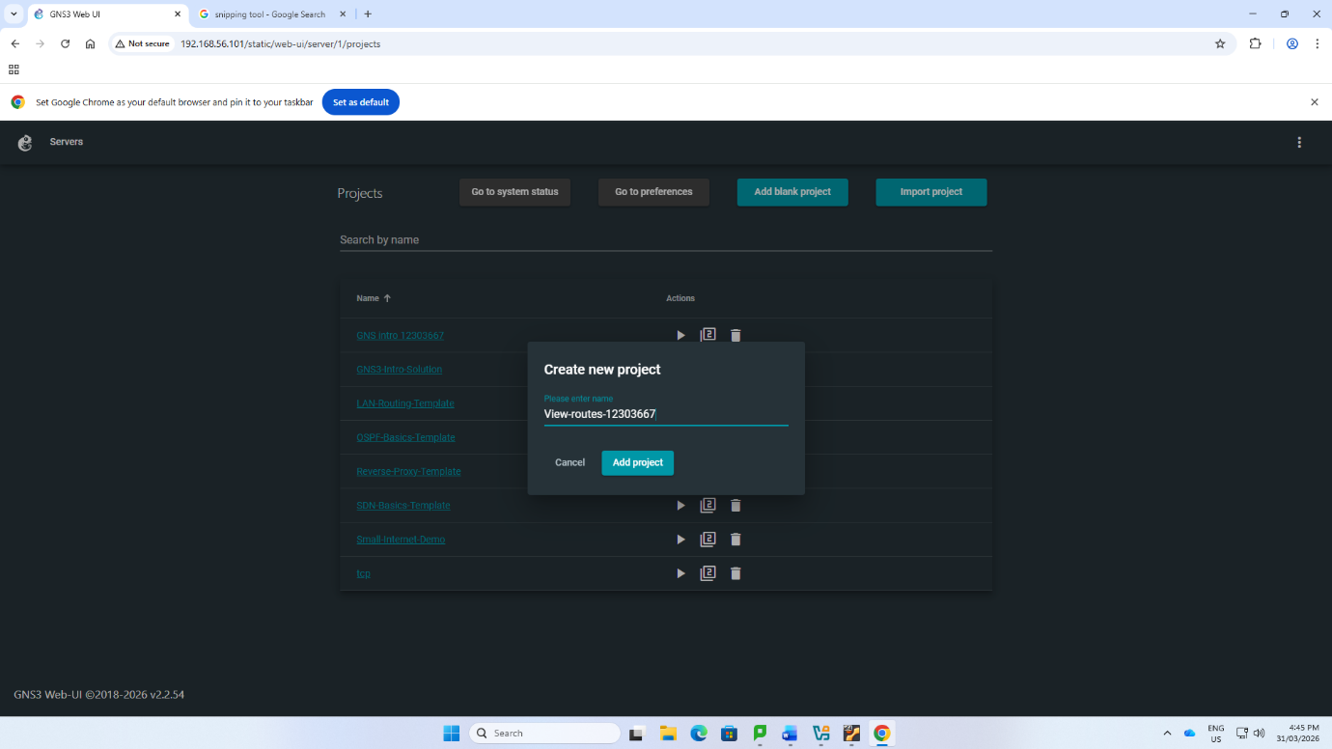

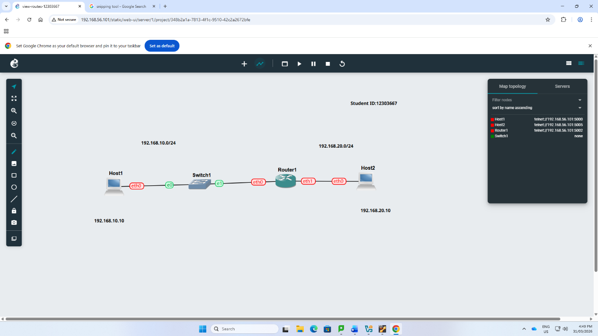

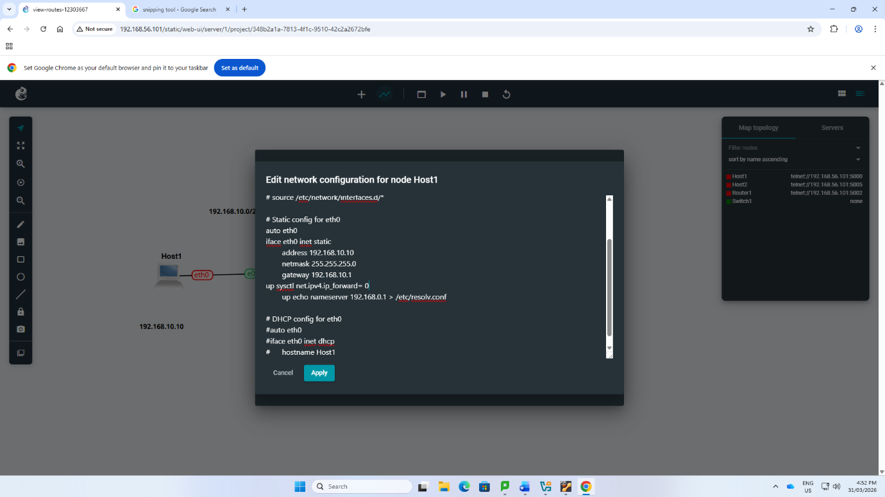
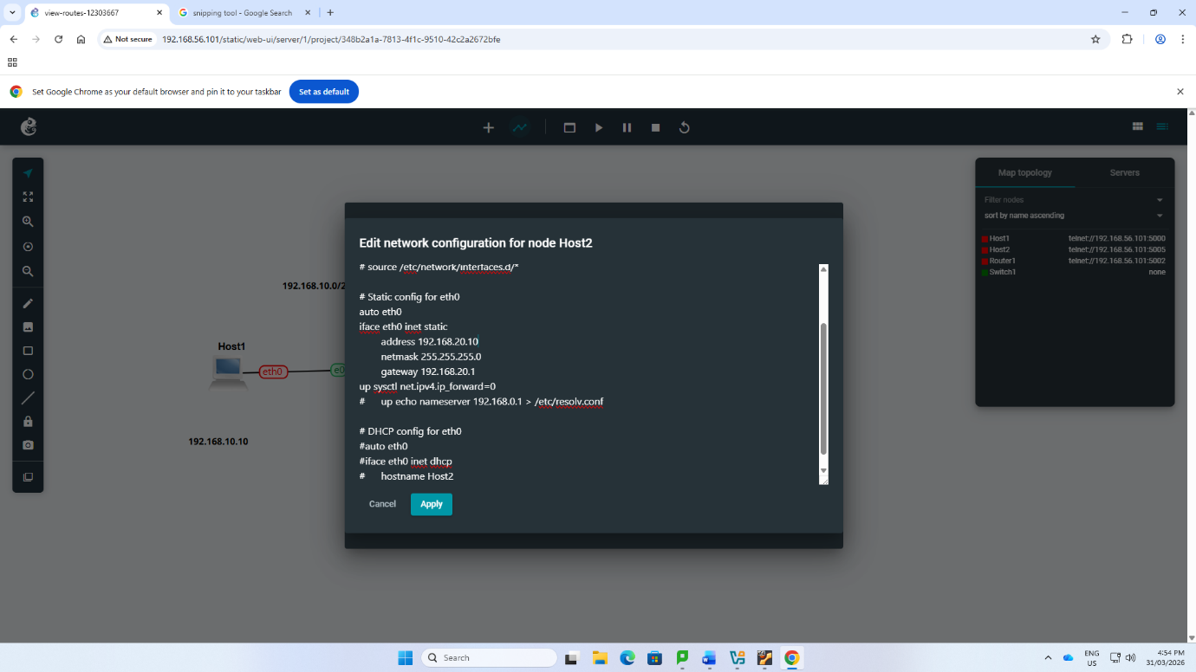
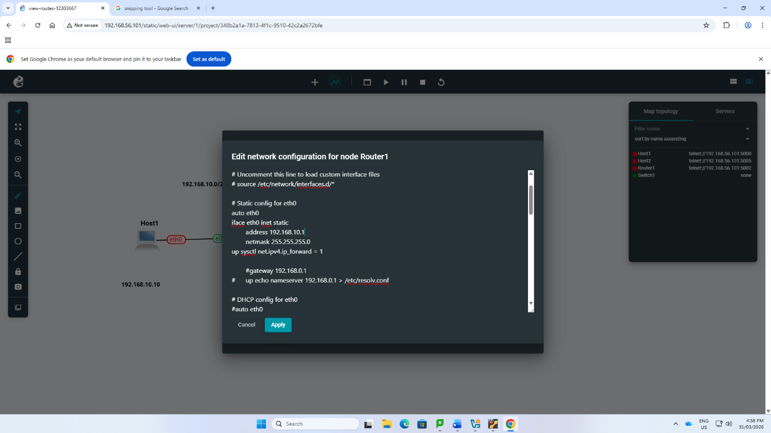
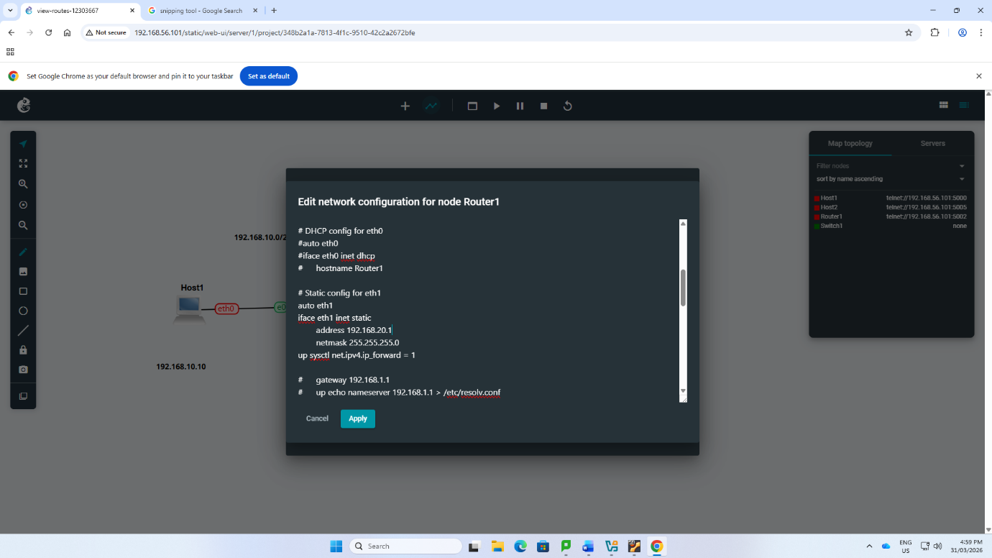
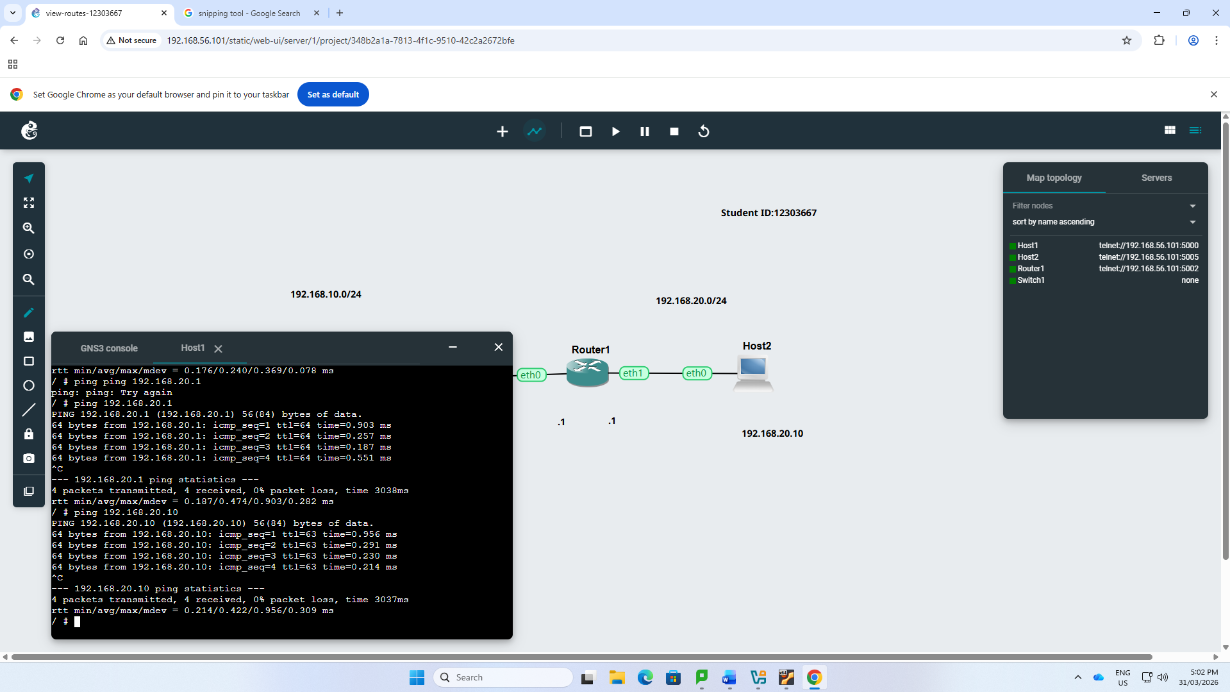
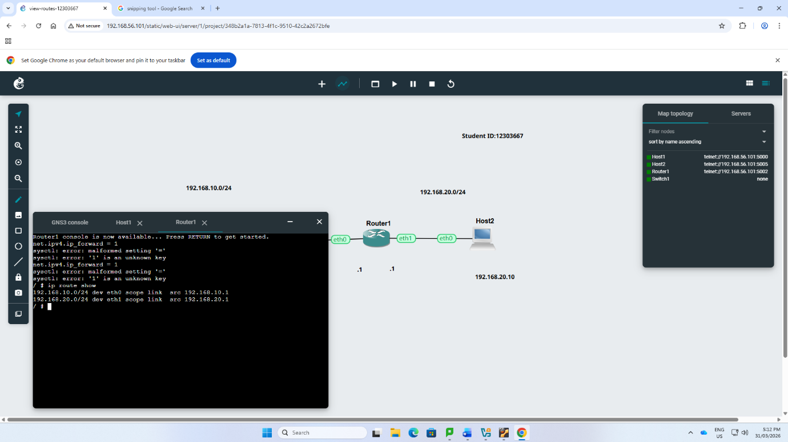
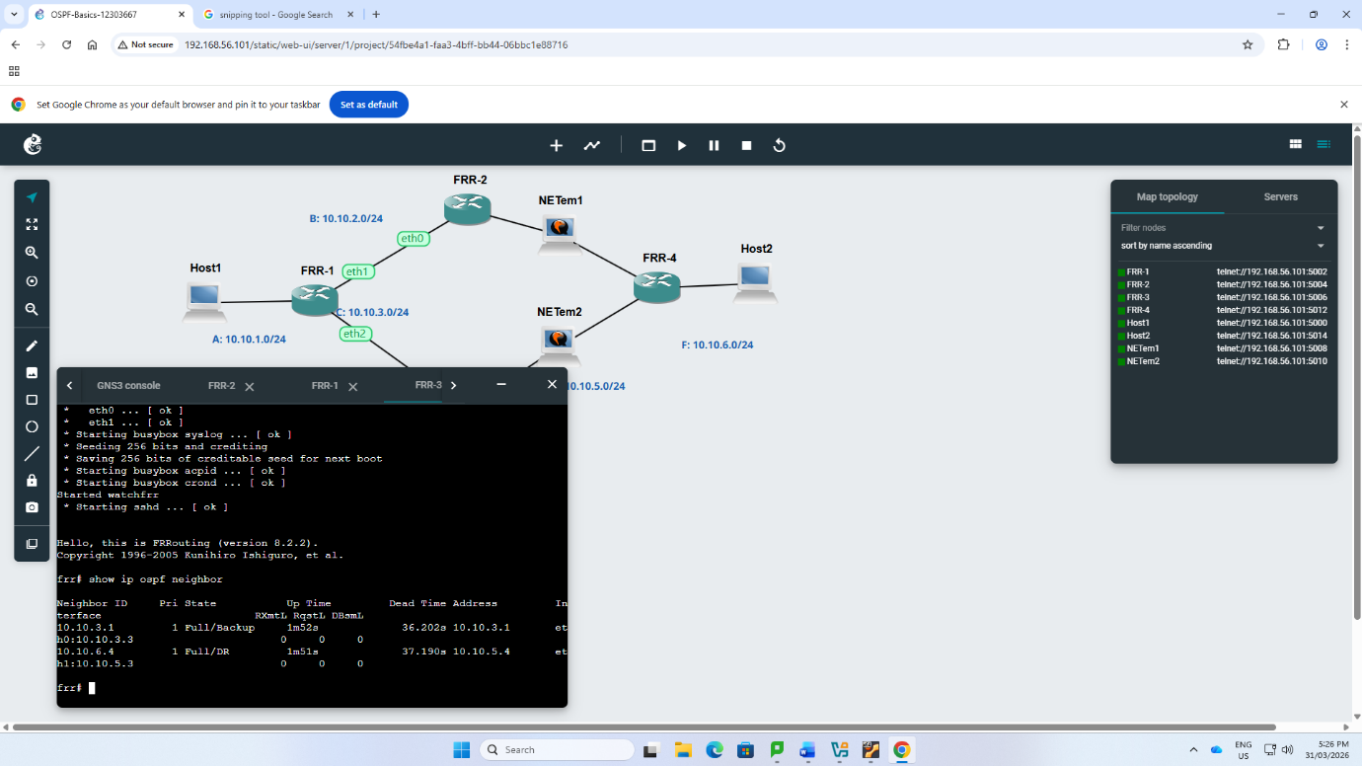
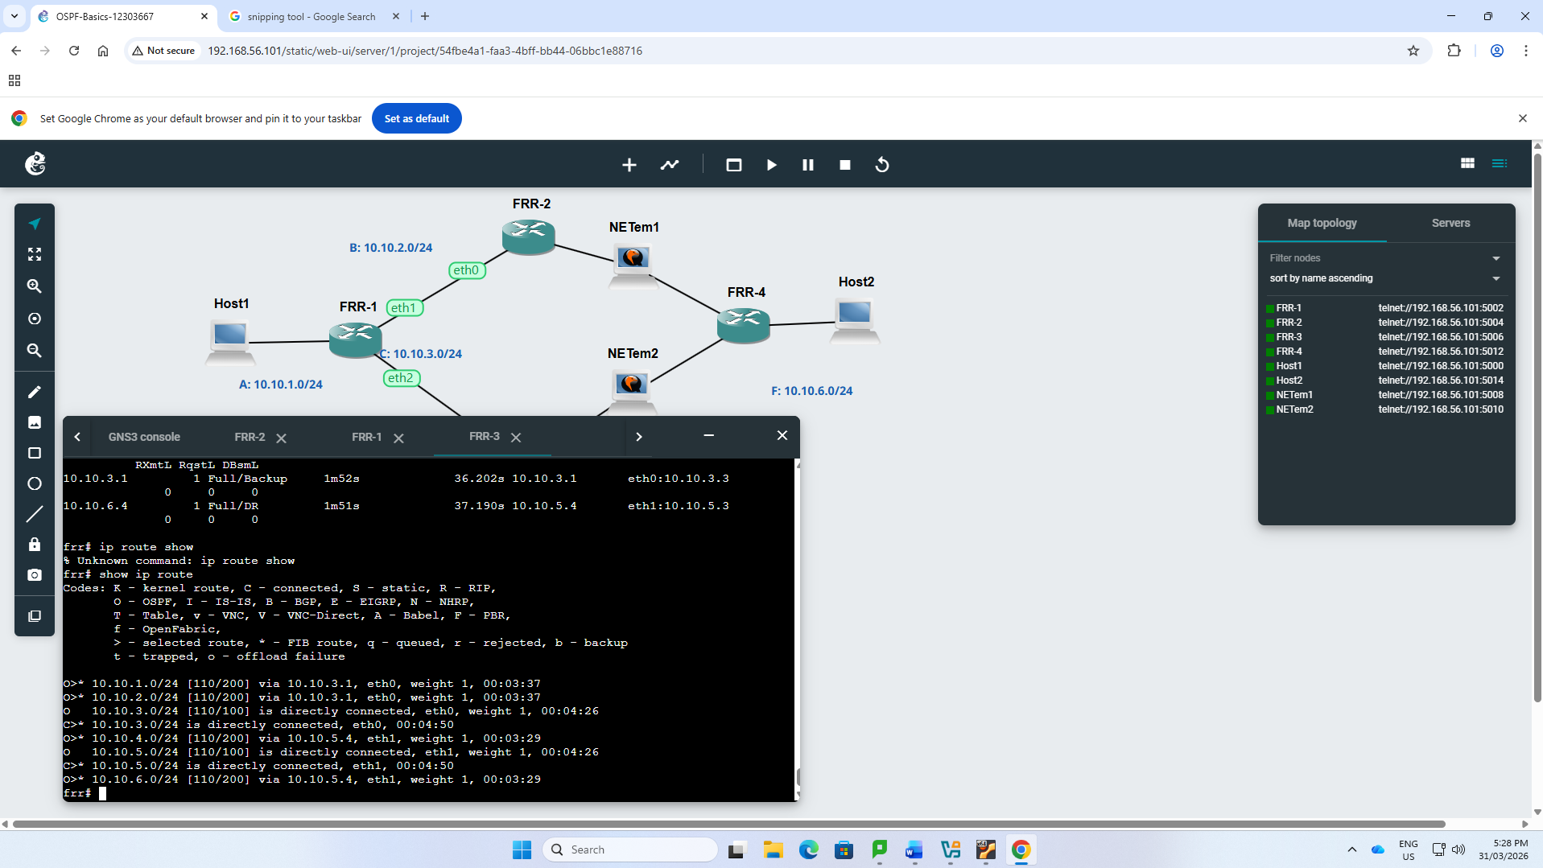

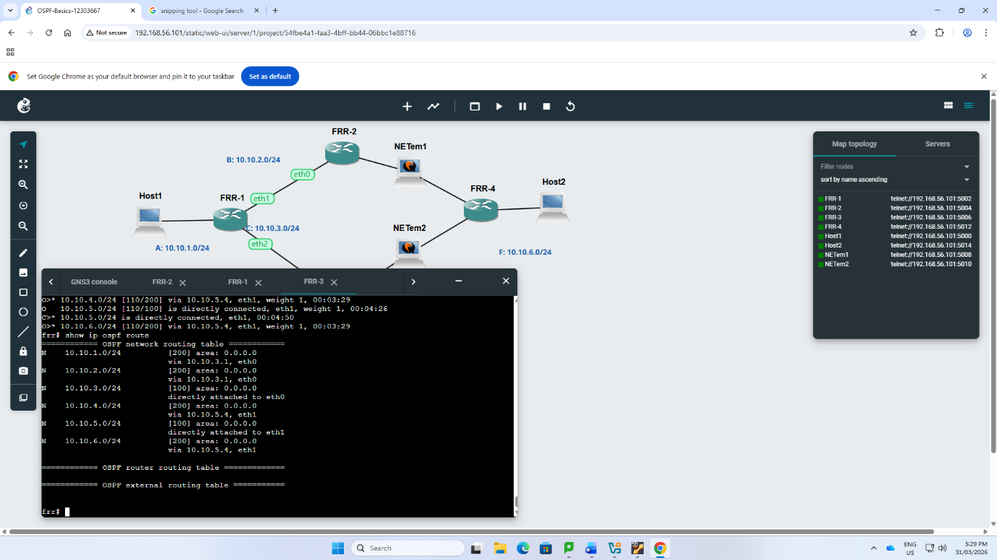

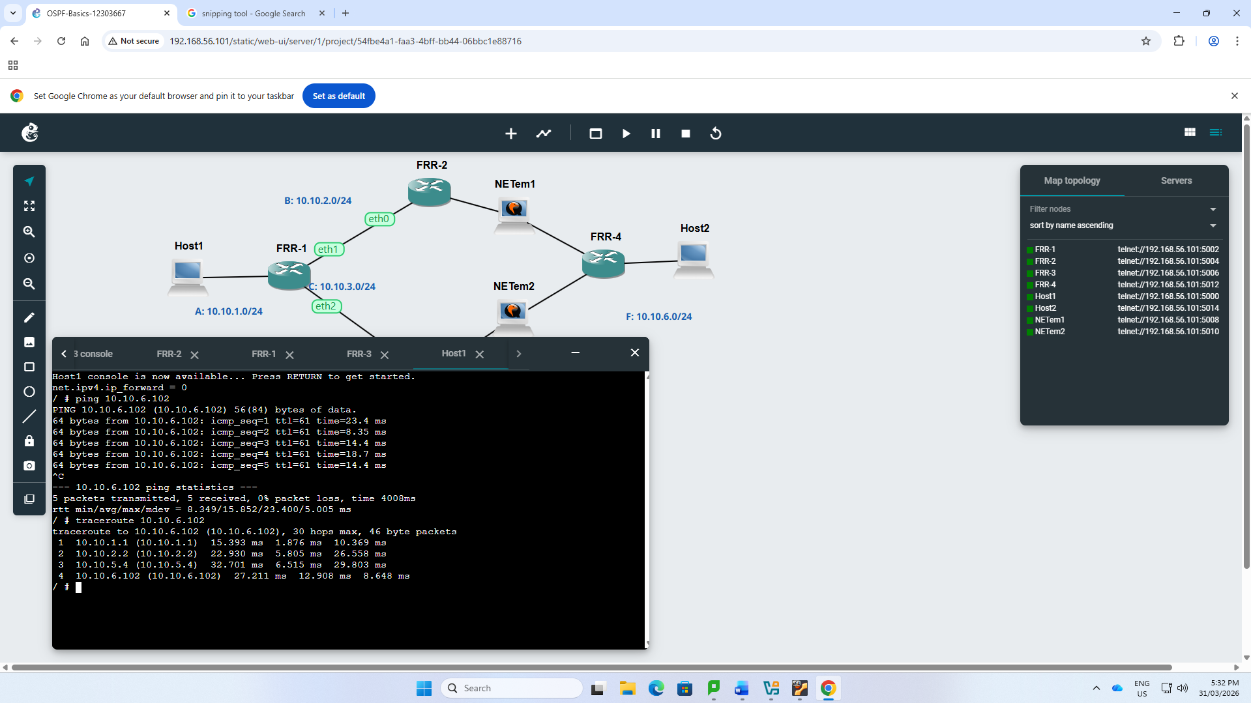

🔍 Reflection

This tutorial made me realize how packets are forwarded between subnets and how routing tables work. I got to know how to look at routing information and how to configure a router to use IP forwarding.

The OSPF assignment revealed that dynamic routing would automatically update routes with changes in the network. Traceroute allowed one to see the route that packets follow. On the whole, this enhanced my knowledge on routing and network behaviour.

